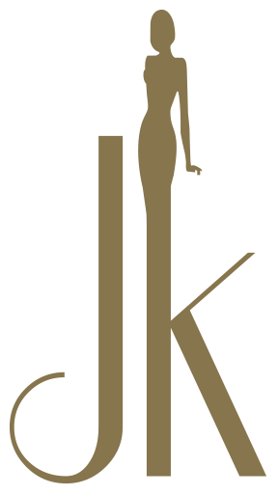

JK SKIN AESTHETICS COVID 19 POLICY
​
All of us have been affected by the coronavirus (COVID-19) pandemic. JK Skin Aesthetics wants to play our part in halting the spread of this virus and have a duty of care to all our customers and employees some of whom fall into a vulnerable category. As a clinic we have complied with our medical bodies to follow strict guidelines to ensure the safety of everyone.
​
We have missed being able to offer you the treatments that we know you love, and we are looking forward to seeing you again as soon as possible. Our priority is to keep you as safe as possible, and prior to re-opening the salon we have implemented a number of changes which we would like to make you aware of.

During the time the clinic has been shut, our Aestheticians have completed the Coronavirus (COVID-19) Infection Prevention and Control course which is accredited by the Guild of Professional Beauty Therapists Ltd, the UK trade body for our industry. JK Skin Aesthetics already have medical practitioners/professionals on our staff that are GDC (General Dental Council) and GMC (General Medical Council) regulated and that are specialist in cross infection. We have since made a number of changes in the way that we operate that you will notice when you next visit.

Booking Appointments

If we/any of our staff feel ill or have symptoms of C0VlD-19, we will self-isolate immediately and not come into the clinic. This may mean that we have to cancel your appointment at short notice. We appreciate that this may be inconvenient, but it is done entirely for your own safety. If your appointment is cancelled, you will be able to re-book again.

If you or any of the people you live with feel ill or display any symptoms of C0VlD-19 – please advise us as soon as possible and DO NOT COME TO THE SALON FOR YOUR APPOINTMENT. If you are feeling unwell or getting over an illness which is not related to Covid 19 PLEASE DON’T VISIT THE CLINIC. We have amended our booking terms and conditions and you will not be charged for any appointments which you miss due to illness.
​
We will stagger diaries times so that not every treatment starts at the same time to keep in-line with social distancing. We also will be increasing the time between appointments so thorough sterilisation and cleaning can be performed between clients.

Visiting the Salon

For your safety and to maintain social distancing, we ask that you attend your appointments as close to the appointment time as possible. Please do not turn up early for appointments as this may mean that you come into contact with other clients who are just leaving. Arriving late for an appointment also may result in your treatment being cancelled and rebooked.

We will continue with our strict cleaning regime of all common surfaces, toilets door handles etc. are wiped clean using disinfectant products between each client.

All tools and equipment will be disinfected and sterilised in line with the specific manufacturers’ instructions and government health authority guidelines for your safety.

Wherever possible we will utilise environmentally, friendly, single use items during a treatment that will be disposed of safely after use in order to protect you from cross infection.

As you enter the clinic you will be provided with shoe/foot coverings and then required to wash your hands with soap and hot water before your treatment, we will also have hand sanitiser available for you to use when you come into the clinic.

We will understand and not be offended if you wish to wear a face mask or wear disposable gloves when you visit the salon and during your treatment if this is appropriate.

Please don’t be surprised or upset if we use personal protective equipment (PPE) during your visit and during your treatment. This will include disposable gloves / face masks / aprons/ hair protectors/ goggles where appropriate. Additional PPE will be worn where required for specific treatments.

We can confirm that the laundering of clinic towels and uniforms is a priority we can assure you that all clinic laundry is washed at 60°C

All disposable items are bagged and safely removed from the treatment area every day.

Our treatments

We have carried out a risk assessment on all treatments and we are confident that we can continue to provide these safely, we have decided that facial treatments will NOT be using steam as this is an air borne vapour and will be replaced with hot towels or facial saunas, a consultation will be held priory to facial treatments as to determine which is more comfortable for the client.

During your treatment

We understand the importance of hand hygiene and we will ensure that we wash our hands in according with NHS recommendations.

We will try to make your treatment as safe, comfortable and enjoyable as possible. If you have any concerns about your treatments, please let us know and we will do what we can to satisfy you.

After the treatment

In order to avoid handling of cash, we would prefer if you could pay for your treatment by card / or in advance using bank transfers.

All of these procedures have been implemented for your safety and that of our staff. We will continue to take advice from the Government and the NHS regarding safe practice and will amend them as necessary.

